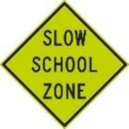
Welcome back students and staff of the Bjorkdale School. The first day of school for the kids was September 4th with teachers heading back August 29th. Please be reminded to slow to 30km/hr when driving through the school zone. We want to keep everyone safe all year long.
SEPTEMBER NEWSLETTER

Residents may have noticed many improvements to the streets of Bjorkdale this summer. The Village council approved a repaving project on the streets of Hara Avenue and Forest View Street. This project was paid for by federal and provincial funded dollars through the Gas Tax program as well as the Village of Bjorkdale reserves for infrastructure projects. Gas tax funding is aimed at contributing toward shared objectives of productivity and economic growth, a clean environment, and strong cities and communities in accordance with the terms and conditions set out in the Canada-Saskatchewan Administrative Agreement on the Federal Gas Tax Fund which came into effect on April 1, 2014.
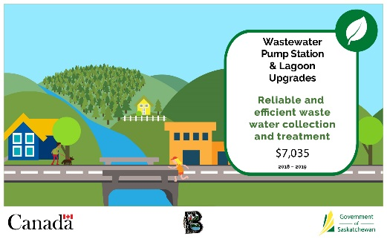
The Village of Bjorkdale was also approved for a Clean Water and Wastewater Fund (CWWF) project. This will upgrade our wastewater pump station and lagoon by updating the electrical components within the pump house, purchase and installation of new pumps as well as upgrade the road to the lagoon. This project is scheduled to be completed by the end of this year.
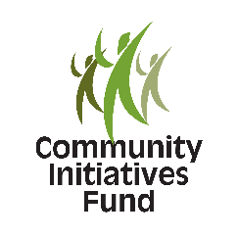
Did you know the Village of Bjorkdale also received a grant of $6,000 that goes towards after school program activities through the Community Initiatives Fund (CIF – provincial funding). Bjorkdale has received funding two (2) years in a row and has been able to provide, art classes to students after school as well as purchase cross country skis for use by all students.
We would like to remind residents that the Village will pick up tree branches and yard debris to be picked up on Mondays. However; this service is for small amounts of tree branches and yard debris. Thank you in advance for your continued cooperation.
Shopping local is important. All of the businesses in town know how important their community is and having a healthy business sector is key to success in any community. Access to local amenities are important factors when deciding to move to a community. A complete business directory can be found www.villagebjorkdale.com
Do you want to become a Bjorkdale First Responder? First Responders are volunteers trained to provide basic life support, care for patients and assist ambulance crews at an emergency scene. Currently Bjorkdale and area is without an active First Responder. If you are interested please contact the Village of Bjorkdale office for more information.

The Village of Bjorkdale would like to welcome the R.M. of Bjorkdale administrative office to Bjorkdale. The R.M. of Bjorkdale purchased the Credit Union Building in March 2018 and have been a pleasant addition to our community. With the purchase of this building the Cornerstone Credit Union and the RM informed the community of the availability of a $15,000 grant for a viable economic project. The Bjorkdale Economic Development Committee alongside the Village of Bjorkdale hope to utilize these funds to improve the community of Bjorkdale in the near future.
BJORKDALE PUBLIC LIBRARY
OPEN: TUESDAY/THURSDAY 9:00am – 4:00pm
WEDNESDAY 3:00pm – 6:00pm
SAVE THE DATE!!!
SUNDAY, NOVEMBER 18th
BJORKDALE TRADE FAIR
Variety of vendors, pick up your community calendar, have a hot lunch. Come out and support the Little Valley Playschool.

KARATE CLASSES
Kuro Tora Dojo of Prince Albert will continue offering Karate classes at Bjorkdale School beginning September 11th. Anyone ages 4-104 are welcome to participate. Classes meet every Tuesday from 7:00-8:30 p.m. Master instructor, Kyoshi Manicke and head instructor, Renshi Manicke teach participants flexibility, balance, coordination, and confidence. Forms, weapon forms, point sparring, and weapon sparring along with martial arts style tumbling and real-world self defense are emphasized. The Bjorkdale Club competes in tournaments throughout the province. Try the first class for free. For more information, email kuro@sasktel.net or call 1-800-814-1950. For questions specific to the Bjorkdale club, you can contact Ashley Babcock.
BJORKDALE PUBLIC LIBRARY
OPEN: TUESDAY/THURSDAYS 9:00 am – 4:00pm &
WEDNESDAY 3:00 – 6:00pm
BJORKDALE CRAFT RETREAT
OCTOBER 27th & 28th , 2018
SAT. & SUN. 9:00am – 8:00pm
Quiliting - 3 sessions $150
Scrapbooking - 3 sessions $150
Painting - 3 sessions $250
Registration and more details contact Linda Hipkins at 306-886-2077
ALL PROCEEDS TO THE EILEEN MOEN LEGACY FUND

The Bjorkdale Choir Club meets weekly on Monday at 1:00pm. They are always looking for new members and if you’re interested please contact Peggy Looby at 886-6449 or Donna Clarke at 873-1278.
Did you know that the Village of Bjorkdale accepts E-transfers and online payments for taxes. Set up the Village of Bjorkdale as a payee on your online banking. Most banks already have the Village of Bjorkdale set up.
ALSO check us out on FACEBOOK! Search Village of Bjorkdale to stay informed.

